Game Design Document (GDD) - Brick Breaker Game
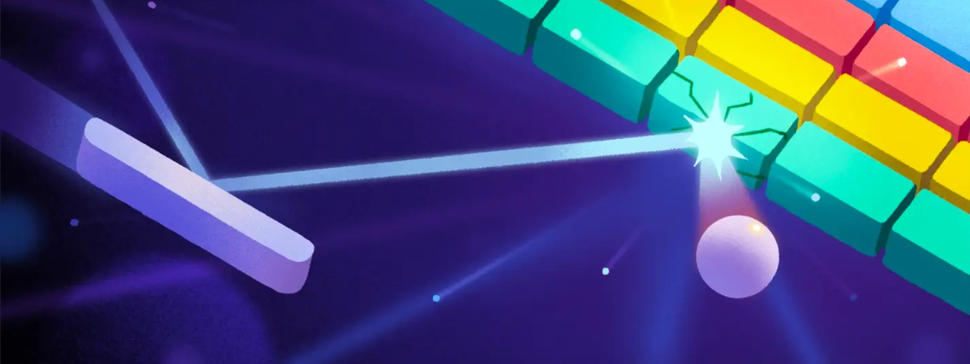
1. Game Overview
Title: Brick Breaker
Genre: Arcade
Platform: PC, Mobile (Android/iOS)
Engine: Unity
Target Audience: Casual gamers, all ages
Game Description: Brick Breaker is a classic arcade game where the player controls a paddle to bounce a ball and break bricks. The goal is to clear all bricks in each level while preventing the ball from falling below the paddle.
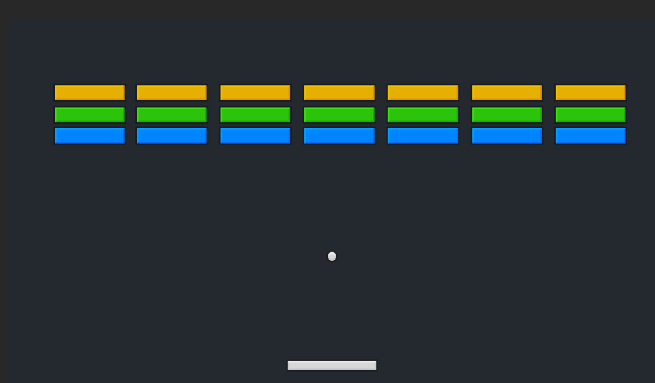

2. Core Gameplay Mechanics
2.1. Player Controls
- Mouse (PC): Move paddle left/right (Optional)
- Touchscreen (Mobile): Swipe left/right to move paddle (Optional)
- Keyboard (PC, Optional): Arrow keys or A/D to move paddle
2.2. Game Loop
- Player launches the ball by pressing a button or tapping the screen.
- The ball moves and bounces off walls, bricks, and the paddle.
- Bricks are destroyed upon contact.
- If the ball falls below the paddle, the player loses a life.
- The level is cleared when all bricks are destroyed.
- The game ends when the player runs out of lives or completes all levels.
2.3. Scoring System
- Breaking a brick: +10 points
- Clearing a level: +100 points (Optional)
- Bonus points for completing levels quickly (Optional)
2.4. Power-ups (Optional)
- Expand Paddle: Increases paddle width for easier control.
- Extra Ball: Adds another ball to the game.
- Fireball: Ball can destroy multiple bricks in one hit.
- Slow Ball: Reduces ball speed for better control.
- Sticky Paddle: Ball sticks to the paddle on impact.

3. Game Levels (Optional)
- Level Progression: Increasing difficulty, more complex brick layouts.
- Brick Types:
  - Normal Brick: Breaks with one hit.
  - Strong Brick: Requires multiple hits to break.
  - Explosive Brick: Destroys surrounding bricks on impact.
  - Unbreakable Brick: Cannot be destroyed; used for obstacles.

4. Art & Sound Design
4.1. Art Style
- Simple and colorful 2D assets
- Smooth animations for ball and paddle
- Minimalist UI design
4.2. Sound & Music(Optional)
- Bouncing sound effects for ball collisions
- Breaking Sound for destroyed bricks
- Background music: Retro arcade-style soundtrack

5. Technical Details
5.1. Unity Features
- Physics Engine: Used for realistic ball movement and collisions.
- UI System: Score display, life counter, pause menu.
- Object Pooling: Optimized performance for bricks and balls.
- Touch & Keyboard Input: Support for multiple devices.
5.2. Monetization (Optional)
- Ads (Mobile version)
- In-app purchases (extra lives, skins)

6. Development Timeline
- Week 1-2: Core mechanics (paddle, ball physics, brick destruction)
- Week 3: Power-ups and UI implementation(Optional)
- Week 4: Level design and difficulty balancing
- Week 5-6: Playtesting and bug fixing(Optional)
- Week 7: Release and marketing(Optional)

7. Future Enhancements(Optional)
- Multiplayer Mode: Competitive mode with real-time paddle battles.
- Level Editor: Players create and share custom levels.
- Themed Skins: Different paddle and ball designs.

8. Conclusion
Brick Breaker is a fun and engaging arcade game with simple mechanics and addictive gameplay. By adding power-ups, various brick types, and smooth controls, the game will provide an enjoyable experience for players of all ages.

